FILE COMPRESSION

ZIP
Create a ZIP Archive:
#zip files file1.txt file2.txt file3.txt file4.txt file5.txt

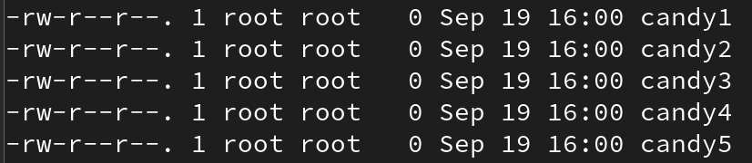

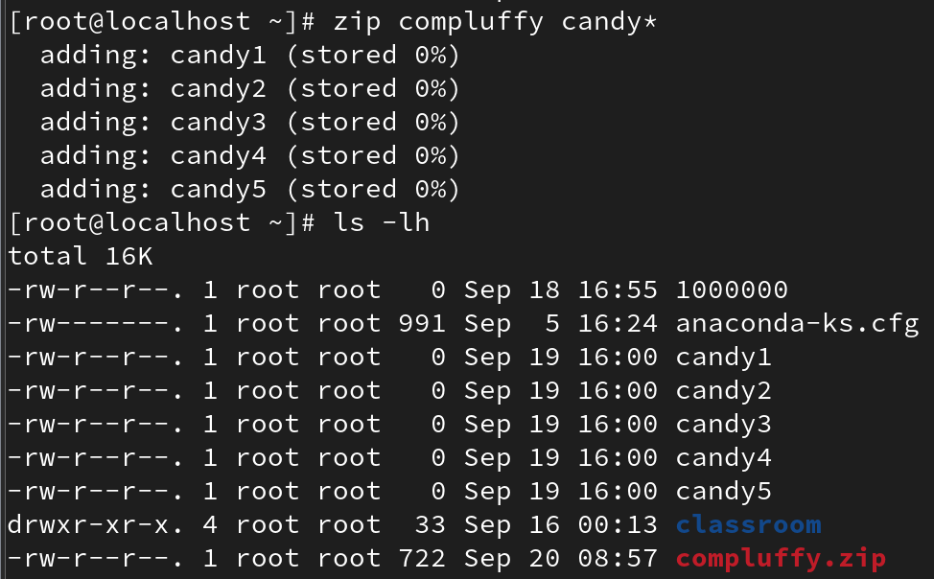

List ZIP File Contents:
#zip -sf files.zip
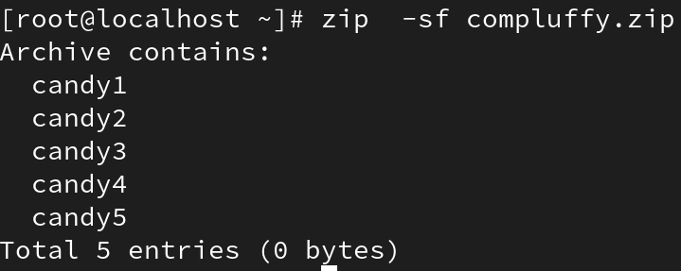

Add a Directory to ZIP Archive:
#zip -r files <directory>

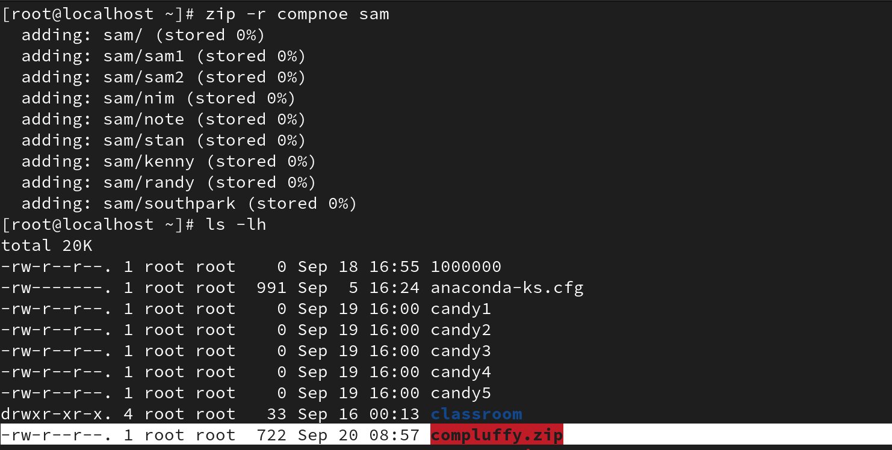

Delete Files From ZIP Archive:
#zip -d <archive file> <files for deletion>
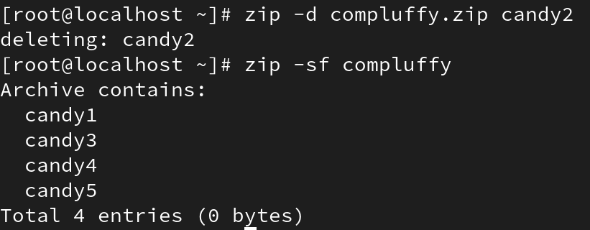

To unzip

#unzip test.zip

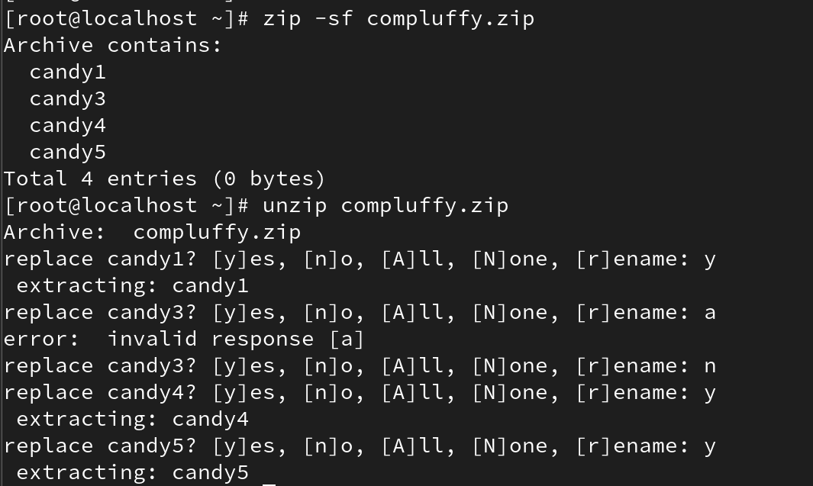

Explanation:
The 'zip' command creates compressed ZIP archives. Options:
-r : Recursively include directories and subdirectories.
-d : Delete specified files from an existing zip file.
-sf : Show the list of files inside the archive.
Example: 'zip -d files.zip file5.txt' removes file5.txt from files.zip.

GZIP
Compressing Files:
#gzip filename
Compress multiple files:
gzip file1 file2 file3 file4
Keep the original file:
#gzip -k filename

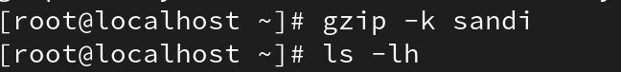

Verbose output:
#gzip -v filename

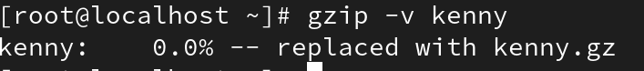

Compress all files in a directory:
#gzip -r directory

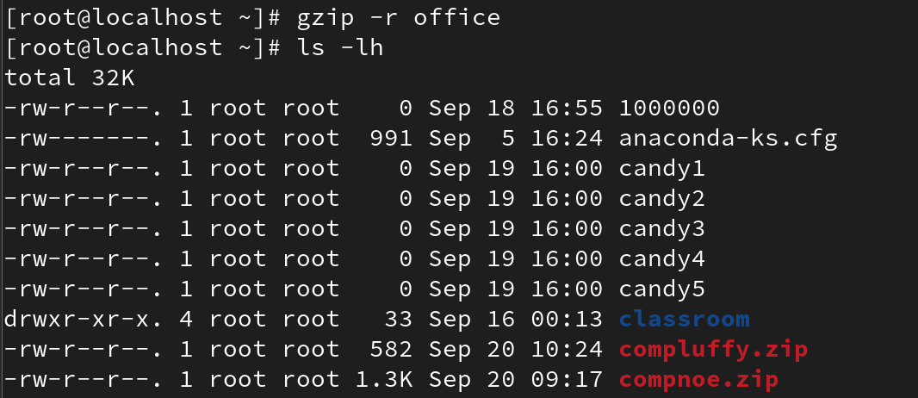

Decompressing Files:
#gzip -d filename.gz or gunzip filename.gz

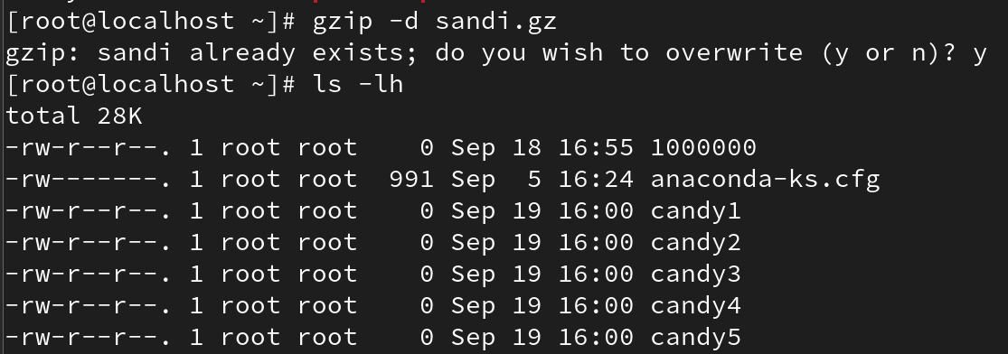

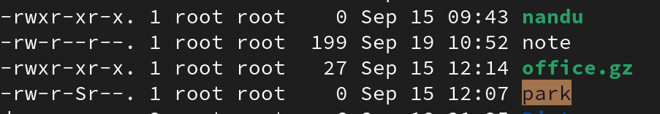

Decompress all files in a directory:
#gzip -dr directory

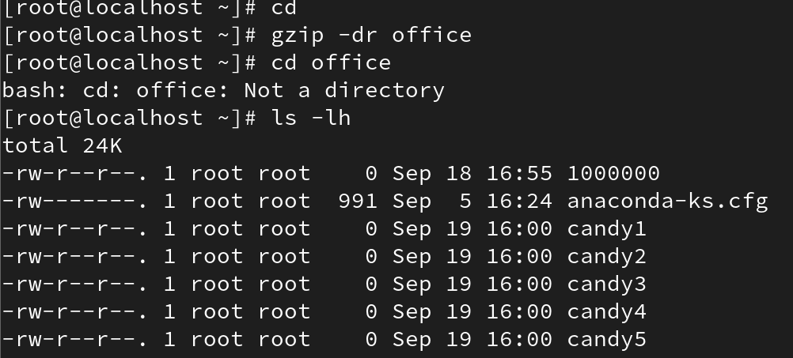

Keep the compressed file:
#gzip -dk filename.gz

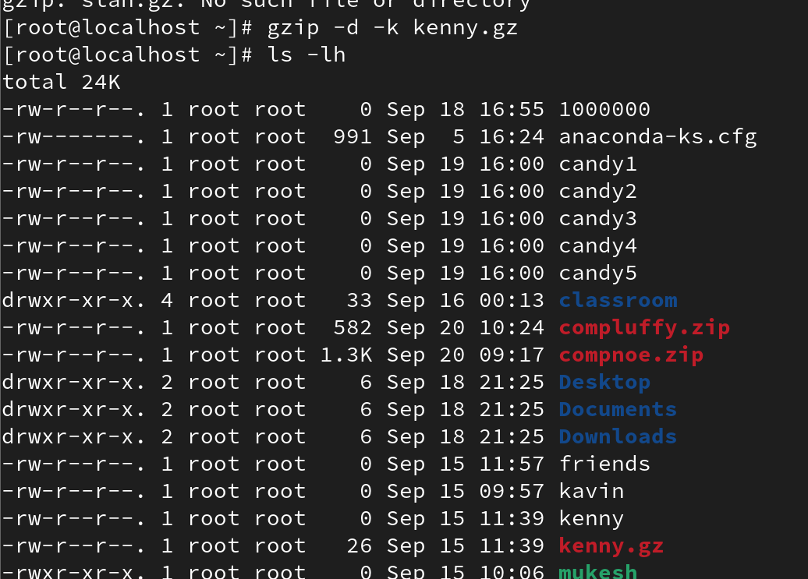

List the Compressed File Contents:
#gzip -l filename

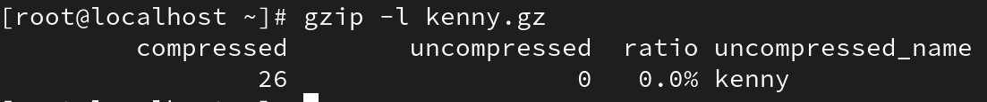
#gzip -lv filename

Explanation:
The 'gzip' command compresses files using the GNU zip algorithm.
-k : Keep the original file.
-v : Verbose, shows compression ratio.
-d : Decompress.
-r : Recursively compress directories.
gzip works on individual files and replaces them with a .gz compressed version unless -k is used.

TAR
Create a tar Archive File in Linux:
tar -cvf etc-backup-14-09-12.tar /etc
c: create, v: verbose, f: file name.
Create tar.gz Archive File:
#tar -cvzf etc-backup-14-09-12.tar.gz /etc

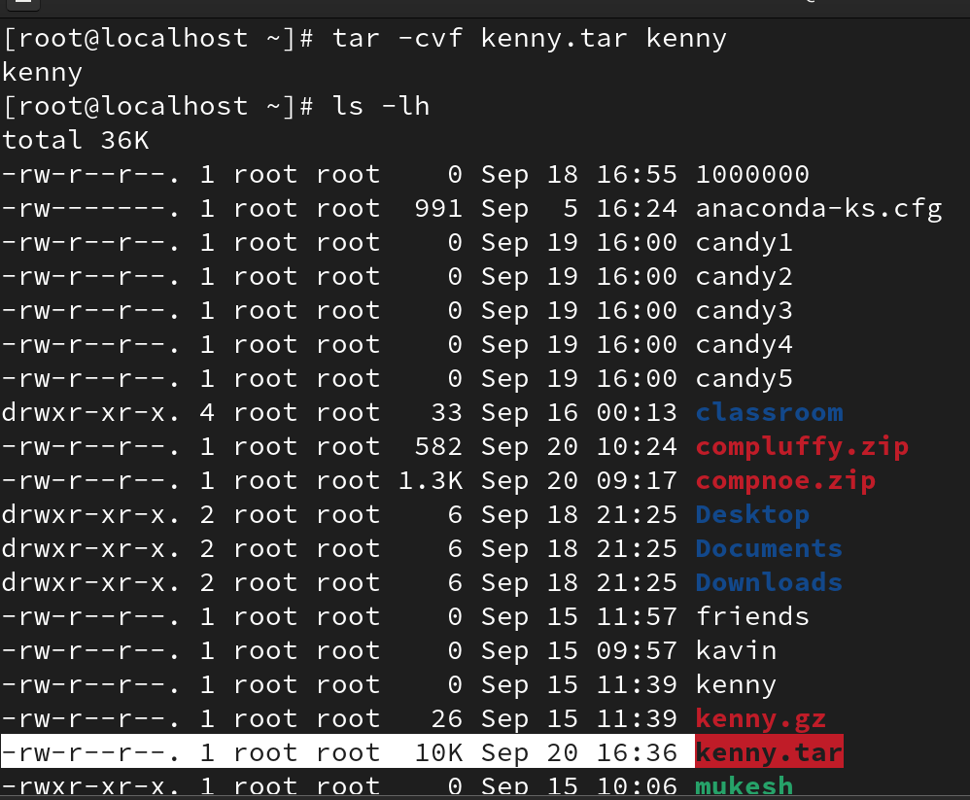

When you work with tar archives, you can compress or decompress them using different algorithms.
Two common compressors are:
• gzip → gunzip (tar.gz)
#tar -cvzf savefile.tar.gz filename
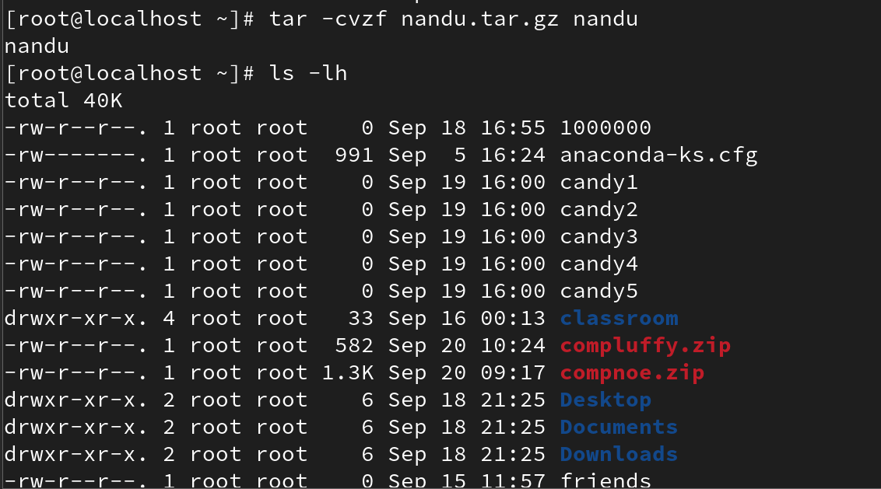

• bzip2 → bunzip(tar.bz2 or tbz)
#tar -cvjf savename.tbz filename
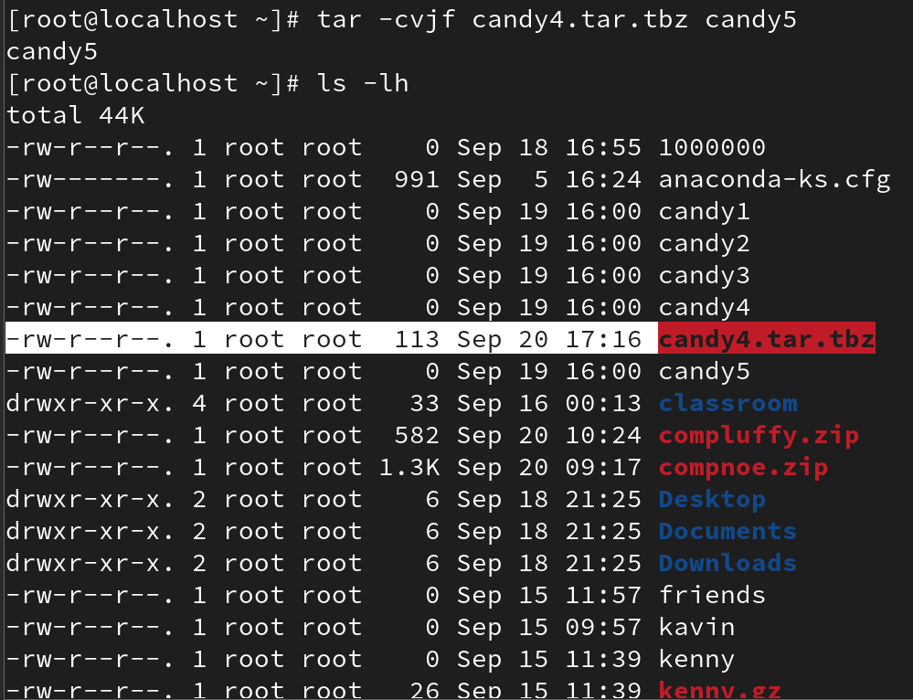

Untar tar Archive File:
#tar -xvf etc-backup.tar

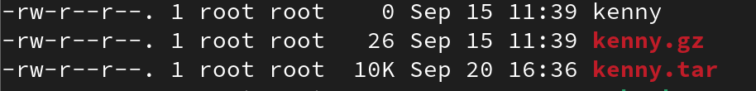

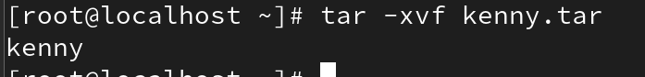

# extract in diffrent directory

#tar -xvf etc-backup.tar -C /mnt # extract to /mnt

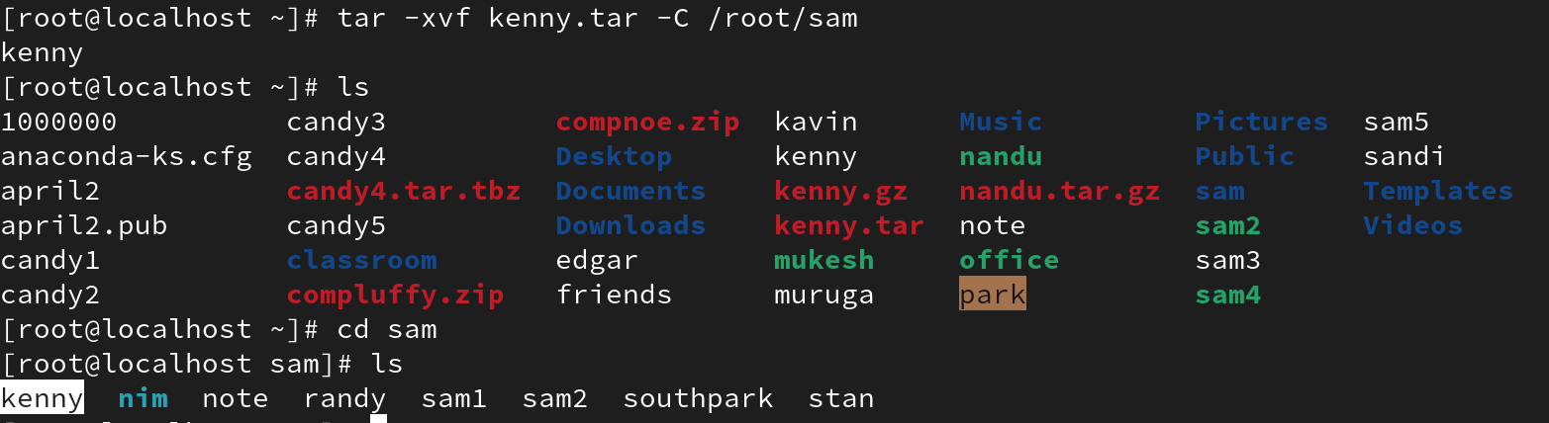

Untar Single or Multiple Files:
#tar -xvf etc-backup.tar passwd group

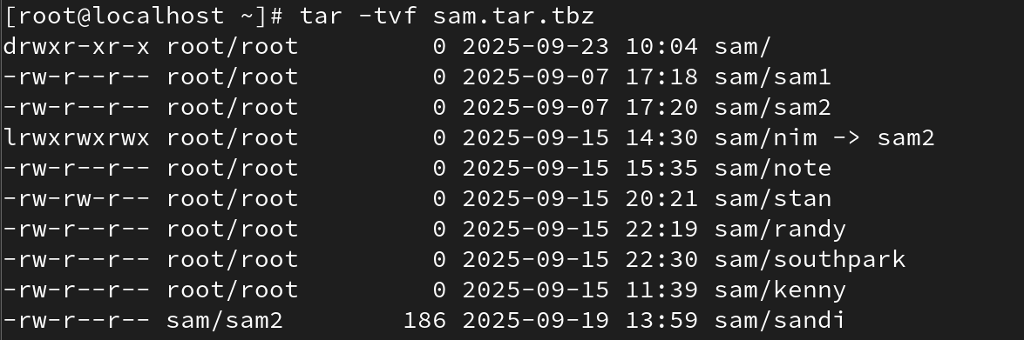

# tar -xvf etc-backup.tar "file1" "file2"

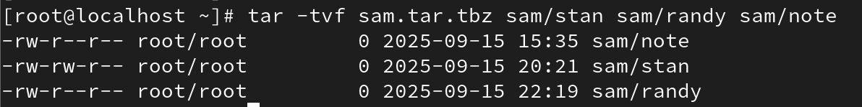

List Content of tar Archive:
#tar -tvf backup.tar
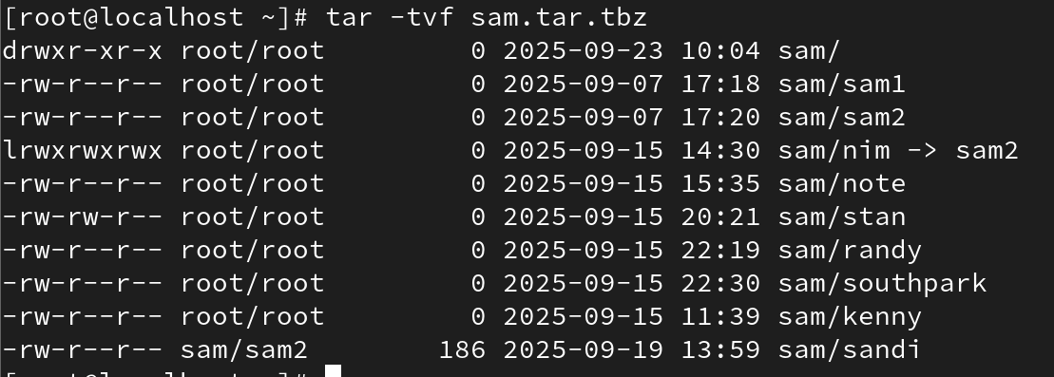

Add Files or Directories to tar Archive:
#tar -rvf backup.tar file1 file2

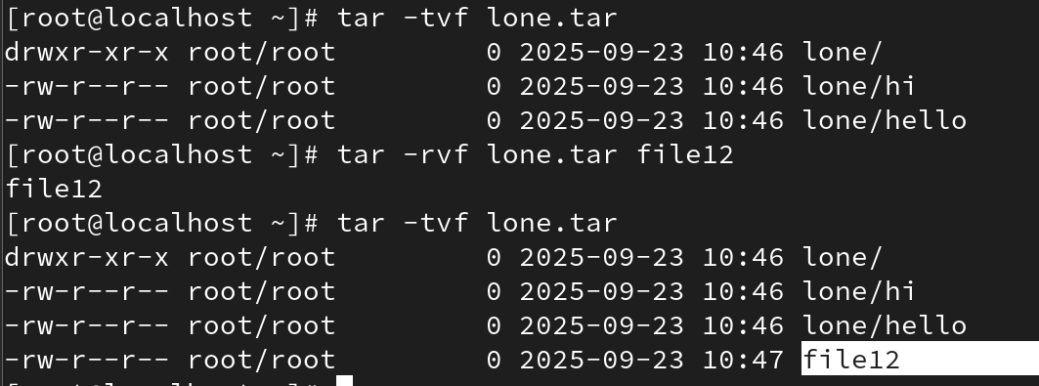

Remove File or Directory from Tar Archive:
#tar --delete -f backup.tar file1.txt

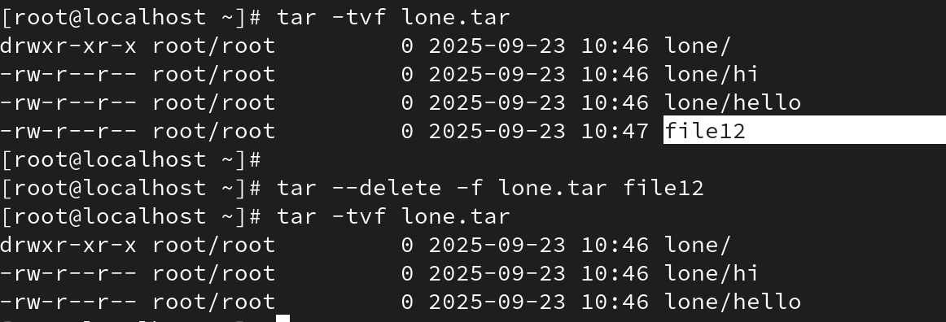

#tar --delete -f backup.tar '/home/tecmint/uploads'
Explanation:
- tar -cvf : create tar archive.
- tar -cvzf : create a compressed tar.gz archive.
- tar -xvf : extract files.
- tar -tvf : list contents.
- tar -rvf : append files to archive.
- tar --delete : remove files or directories from a tar archive.
Important: '--delete' only works on uncompressed .tar files. For .tar.gz or .tar.bz2, you must first decompress the file, delete the entry, and recompress.

